Day 25 - 9th August- 113195064 - Bondili Bhavya Charitha
Task:1 – Bridge method
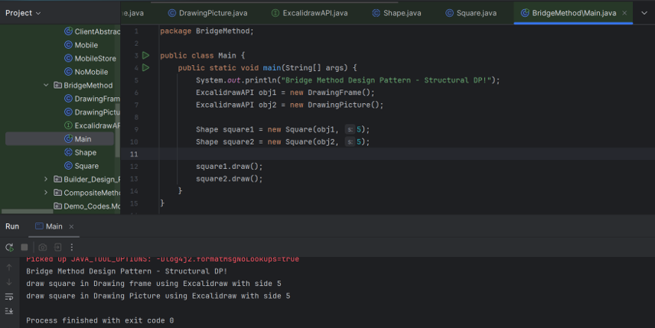

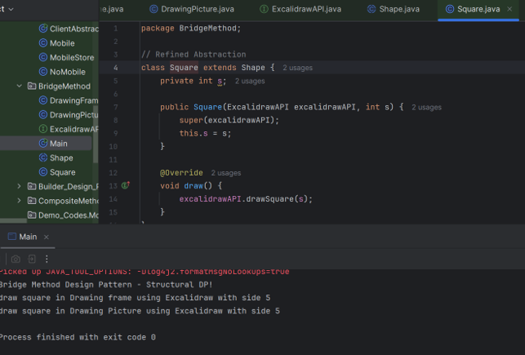
Task:2 – Composite
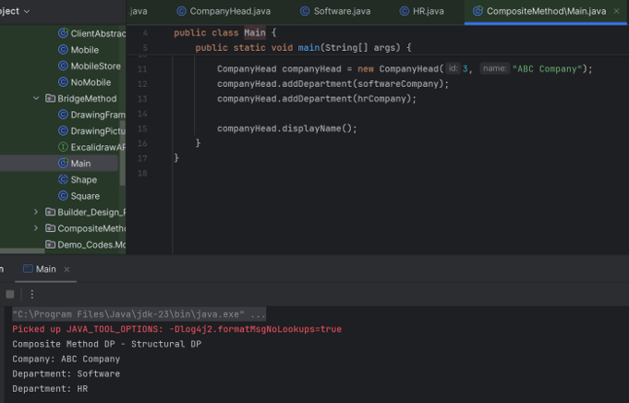

Task:3 – Façade
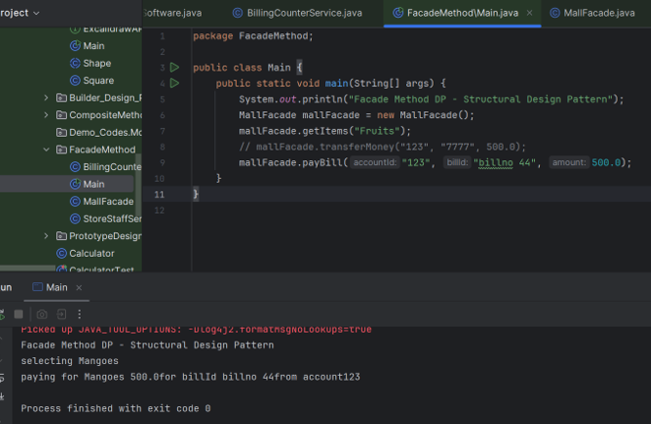
Proxy Method:
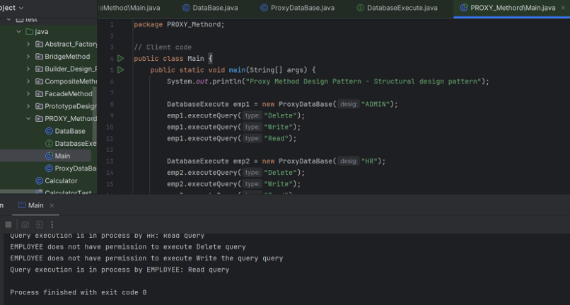

Command Pattern:
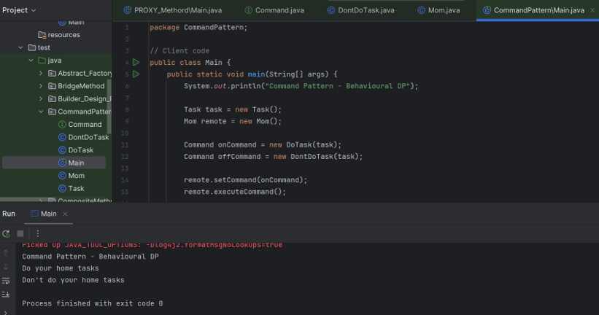

Adapter Method:
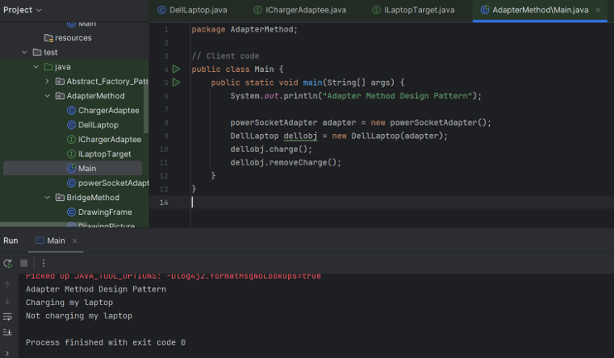

Home Task:1 - Bridge Method
// Bridge Design Pattern - Java Implementation

// Implementor Interface
interface Device {
void turnOn();
void turnOff();
void setVolume(int percent);
}

// Concrete Implementor 1
class TV implements Device {
@Override
public void turnOn() {
System.out.println("TV is now ON");
}

@Override
public void turnOff() {
System.out.println("TV is now OFF");
}

@Override
public void setVolume(int percent) {
System.out.println("TV volume set to " + percent + "%");
}
}

// Concrete Implementor 2
class Radio implements Device {
@Override
public void turnOn() {
System.out.println("Radio is now ON");
}

@Override
public void turnOff() {
System.out.println("Radio is now OFF");
}

@Override
public void setVolume(int percent) {
System.out.println("Radio volume set to " + percent + "%");
}
}

// Abstraction
class RemoteControl {
protected Device device;

public RemoteControl(Device device) {
this.device = device;
}

public void togglePower(boolean on) {
if (on) {
device.turnOn();
} else {
device.turnOff();
}
}

public void changeVolume(int percent) {
device.setVolume(percent);
}
}

// Refined Abstraction
class AdvancedRemoteControl extends RemoteControl {

public AdvancedRemoteControl(Device device) {
super(device);
}

public void mute() {
device.setVolume(0);
System.out.println("Device muted");
}
}

// Client Code
public class BridgePatternDemo {
public static void main(String[] args) {
// Using basic remote with TV
Device tv = new TV();
RemoteControl remote = new RemoteControl(tv);
remote.togglePower(true);
remote.changeVolume(50);
remote.togglePower(false);

System.out.println();

// Using advanced remote with Radio
Device radio = new Radio();
AdvancedRemoteControl advancedRemote = new AdvancedRemoteControl(radio);
advancedRemote.togglePower(true);
advancedRemote.changeVolume(30);
advancedRemote.mute();
advancedRemote.togglePower(false);
}
}
Home Task:2 – Fly Weight
import java.util.HashMap;
import java.util.Map;

// Flyweight Interface
interface Tree {
void display(int x, int y); // External state: position
}

// Concrete Flyweight
class MangoTree implements Tree {
private final String type; // Intrinsic state

public MangoTree() {
this.type = "Mango";
System.out.println("Creating MangoTree object...");
}

@Override
public void display(int x, int y) {
System.out.println("Displaying " + type + " tree at (" + x + ", " + y + ")");
}
}

class CoconutTree implements Tree {
private final String type;

public CoconutTree() {
this.type = "Coconut";
System.out.println("Creating CoconutTree object...");
}

@Override
public void display(int x, int y) {
System.out.println("Displaying " + type + " tree at (" + x + ", " + y + ")");
}
}

// Flyweight Factory
class TreeFactory {
private static final Map<String, Tree> treeMap = new HashMap<>();

public static Tree getTree(String type) {
Tree tree = treeMap.get(type);
if (tree == null) {
switch (type) {
case "Mango":
tree = new MangoTree();
break;
case "Coconut":
tree = new CoconutTree();
break;
default:
throw new IllegalArgumentException("Unknown tree type: " + type);
}
treeMap.put(type, tree);
}
return tree;
}
}

// Client
public class FlyweightDemo {
public static void main(String[] args) {
Tree mango1 = TreeFactory.getTree("Mango");
mango1.display(10, 20);

Tree mango2 = TreeFactory.getTree("Mango");
mango2.display(15, 25);

Tree coconut1 = TreeFactory.getTree("Coconut");
coconut1.display(30, 40);

Tree coconut2 = TreeFactory.getTree("Coconut");
coconut2.display(35, 45);
}
}
Home Task:3 – Decorator
// Decorator Design Pattern - Integrated Java Implementation

// Component Interface
interface TextEditor {
void write(String text);
}

// Concrete Component
class BasicTextEditor implements TextEditor {
@Override
public void write(String text) {
System.out.println("Writing text: " + text);
}
}

// Abstract Decorator
abstract class EditorDecorator implements TextEditor {
protected TextEditor editor;

public EditorDecorator(TextEditor editor) {
this.editor = editor;
}

@Override
public void write(String text) {
editor.write(text);
}
}

// Concrete Decorator 1
class SpellCheckDecorator extends EditorDecorator {
public SpellCheckDecorator(TextEditor editor) {
super(editor);
}

@Override
public void write(String text) {
super.write(text);
checkSpelling(text);
}

private void checkSpelling(String text) {
System.out.println("SpellCheck: Checking spelling for \"" + text + "\"");
}
}

// Concrete Decorator 2
class GrammarCheckDecorator extends EditorDecorator {
public GrammarCheckDecorator(TextEditor editor) {
super(editor);
}

@Override
public void write(String text) {
super.write(text);
checkGrammar(text);
}

private void checkGrammar(String text) {
System.out.println("GrammarCheck: Checking grammar for \"" + text + "\"");
}
}

// Client Code
public class DecoratorDemo {
public static void main(String[] args) {
// Basic editor
TextEditor basicEditor = new BasicTextEditor();

// Add spell check
TextEditor spellCheckedEditor = new SpellCheckDecorator(basicEditor);

// Add grammar check on top of spell check
TextEditor fullyFeaturedEditor = new GrammarCheckDecorator(spellCheckedEditor);

// Use the decorated editor
fullyFeaturedEditor.write("This is a sample sentence");
}
}

